

**DATE : May 30, 2020**

**TO : ALL CONCERNED**

**SUBJECT : ENROLMENT**

For your reference, we are forwarding to you the “On-line Enrolment Policies and Guidelines under the New Normal effective Academic Year 2020-2021 for your information and dissemination to all concerned:

Thank you for your attention and cooperation.

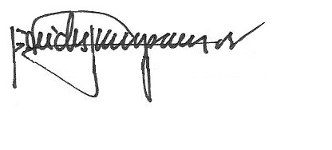

REV. FR. CRISTOPHER C. MASPARA, OAR

President

/bvs